Create a cluster and deploy the image.

# Step one:

Create a cluster, a cluster is a group of worker nodes where you can deploy your pods.

Go to the Kubernetes engine, then press on clusters:

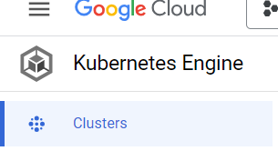

Then press on create:

Name your cluster, and hit create:

After the cluster is created, press on the three dots next to the cluster and press connect:

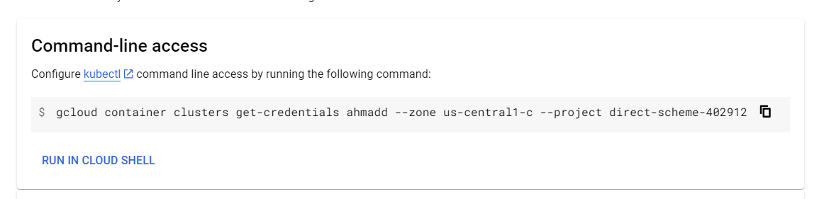

Copy this command and paste it in power shell:

# Step two:

Create your deployment YAML file, which will create a pod for you and place (schedule) that pod on a node and that pod contains your container:

Example:

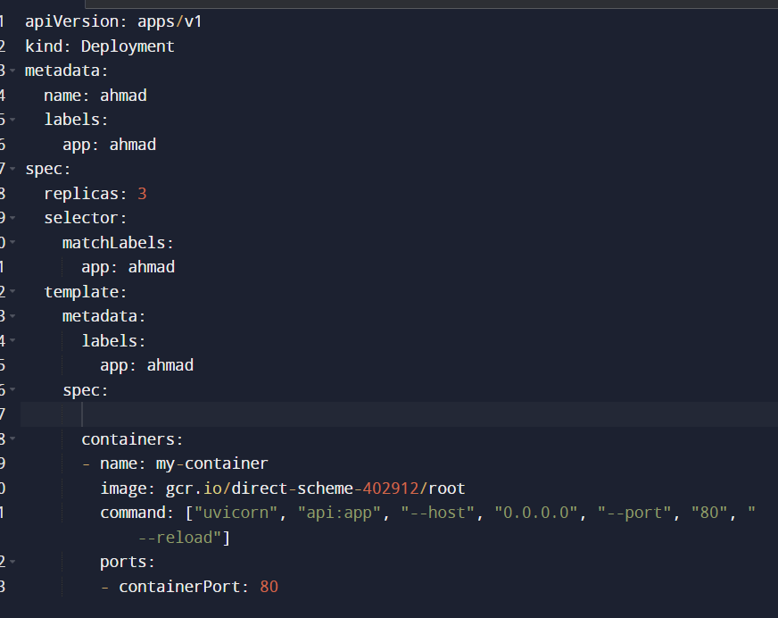

After you have created your deployment/pod file you need to create a service file which is a load balancer that will get your request from the browser (public internet) and route it to the pod.

Example:

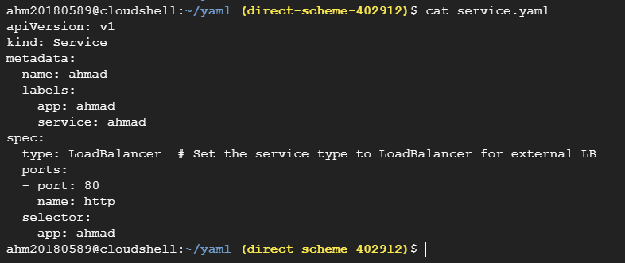

# Step three:

Run this command and ensure all of the files are in the same directories:

“kubectl apply -f .”

After that you can check if your pods are deployed successfully using “kubectl get pods”

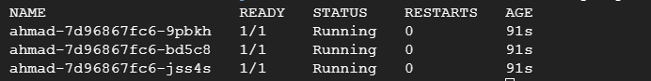

Then run this command to view the service which we have created and get the load balancer IP:

“kubectl get svc”



Copy the IP address and paste it onto the browser alongside the port, and access your API

SIMPLE AND STUIPD